

Anjuman-I-Islam’s
AKBAR PEERBHOY COLLEGE OF COMMERCE & ECONOMICS
M. S. Ali Road, Do Taaki, Grant Road (E), Mumbai-8.

PRACTICAL JOURNAL SUBMITTED TO
T.Y. B.Sc. (Data Science)
Semester - VI

Internet of Things
University of Mumbai

By

Under the guidance of
Prof. Sana Khan
DEPARTMENT OF DATA SCIENCE
AKBAR PEERBHOY COLLEGE OF COMMERCE & ECONOMICS
Academic Year (2025 – 2026)



Anjuman-I-Islam’s
“AKBAR PEERBHOY COLLEGE OF COMMERCE & ECONOMICS”
M.S. Ali Road, Mumbai - 400008

CERTIFICATE

This is a certify that of The class T.Y.B. Sc - Data Science Roll No: 46 University Exam Seat No: has satisfactorily completed the Practical Journal in the subject of Internet of Things as Prescribed in the syllabus of ThirdYear Bachelor of Science in Data Science During the academic year 2025 – 2026

B.Sc. Data Science External Examiner Lecturer-in-Charge Coordinator (Signature) (Signature) (Signature)

Index

Practical  No. | Name of Experiment | Date | Signature
Q1. | Displaying different LED patterns with Raspberry Pi. | 03/12/2025
Q2. | Displaying Time over 4-Digit 7-Segment Display  using Raspberry Pi | 10/12/2025
Q3. | Raspberry Pi Based Oscilloscope. | 17/12/2025
Q4. | Controlling Raspberry Pi with telegram bot. | 02/01/2026
Q5. | Raspberry Pi GPS Module Interfacing. | 07/01/2026
Q6. | IoT based Web Controlled Home Automation  using Raspberry Pi. | 16/01/2026
Q7. | Visitor Monitoring with Raspberry Pi and Pi Camera. | 04/02/2026
Q8. | Interfacing Raspberry Pi with RFID. | 13/02/2026

Internet of Things # Practical No: 1

Name |  | Roll No:
Class | T.Y.B.Sc. Data Science | Seat Number:
Subject / Topic | Internet of Things
Topic | Displaying different LED patterns with Raspberry Pi.

Practical No: 1 Displaying different LED patterns with Raspberry Pi.

Requirement:
- Connecting Jumper Wires (Female to Female).
- 8 LED Display Board.

Hardware Connectivity:
  - Connect the GPIO11, GPIO13, GPIO15(pin 11, pin 13, pin 15) on Raspberry Pi.
  - Connect another end on 8 LED Board.
  - Connect the GPIO6(pin 6) on Raspberry Pi for Ground.
  - Connect another end on ground of 8 LED Board.

Source Code:
import RPi.GPIO as GPIO from time import sleep # Set up GPIO mode
GPIO.setmode(GPIO.BOARD)
# Define pin numbers pins = [11, 13, 15]
# Set up pins as output for pin in pins:
GPIO.setup(pin, GPIO.OUT)

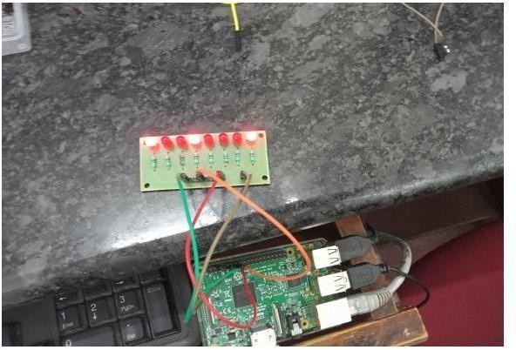
# Loop to toggle LEDs 10 times for i in range(10):
for pin in pins: GPIO.output(pin, True) print(f"Pin {pin} ON") sleep(2) GPIO.output(pin, False)
print(f"Pin {pin} OFF") sleep(2)
print("DONE") # Cleanup GPIO GPIO.cleanup()

Output:

Internet of Things # Practical No: 2

Name |  | Roll No:
Class | T.Y.B.Sc. Data Science | Seat Number:
Subject / Topic | Internet of Things
Topic | Displaying Time over 4-Digit 7-Segment Display using Raspberry Pi.

Practical No: 2 Displaying Time over 4-Digit 7-Segment Display using Raspberry Pi.

Requirement:
- TM1637 4-digit seven segment Display board.
- Connecting Jumper Wires (Female to Female).

Hardware Connectivity:
- Connect your 4 digit 7 segment display with Raspberry Pi's GPIO Pins

TM16737 Board | Function | Rpi Physical pin | Raspberry Pi  Function
GND | Ground | 6 | GND
VCC | Power | 2 | Power Supply
DIO | Data In | 18 | GPIO24
CLK | Clock | 16 | GPIO23

Other Requirement:
- Now to download libraries, open Web Browser on your Raspberry Pi and log on to the following link: raspberrypi- examples/actor-led-7segment-4numbers at master · timwaizenegger/raspberrypi-examples · GitHub . Click on the actor-led-7segment-4numbers.zip folder and Now click on Download Button to download the file.

- Now on your rpi move to /home/pi/Downloads/ location to find the zip file downloaded.
- Unzip the file and try to execute the different example codes present in that folder in Python Idle.
- create a new file, write the code given below and save it in the same folder.
Source Code:
import sys import time
import datetime
import RPi.GPIO as GPIO import tm1637
# Initialize TM1637 Display (CLK = GPIO 23, DIO = GPIO 24)
Display = tm1637.TM1637(clk=23, dio=24, brightness=tm1637.BRIGHT_TYPICAL) Display.Clear()
Display.SetBrightness(1)
# Infinite loop to update the display with current time while True:
now = datetime.datetime.now() hour = now.hour
minute = now.minute second = now.second
# Format time as HH:MM
current_time = [int(hour / 10), hour % 10, int(minute / 10), minute % 10] # Display the time on the 7-segment display Display.Show(current_time)
Display.ShowDoublepoint(second % 2) # Blink colon every second
time.sleep(1)

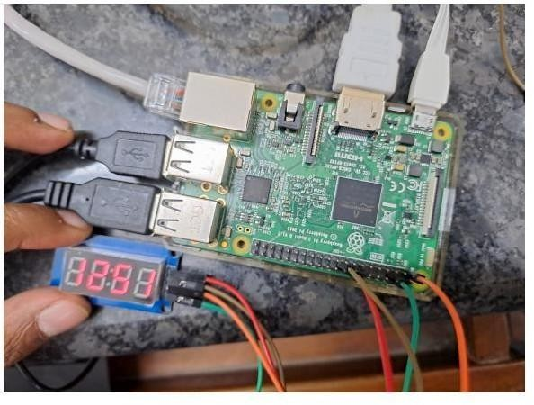
Output:

Internet of Things # Practical No: 3

Name |  | Roll No:
Class | T.Y.B.Sc. Data Science | Seat Number:
Subject / Topic | Internet of Things
Topic | Raspberry Pi Based Oscilloscope.

Practical No: 3 Raspberry Pi Based Oscilloscope.

Requirement:
- Raspberry Pi Model A/B/B+
- ADS1115 ADC
- Breadboard
- Jumper Wires
ADS1115 ADC chip is used to convert the analog input signals to digital signals which can be visualized with the Raspberry Pi. This chip is important because the Raspberry Pi does not have an onboard analog to digital converter (ADC).
Software Requirements:
- Raspbian Stretch OS
- Adafruit module for interfacing with the ADS1115 ADC chip
- Python Module matplotlib used for data visualization.

  - Connect your ADC with Raspberry Pi's GPIO Pins

ADS1115 ADC | Pin Number | GPIO Number
VDD | Pin 17 | 3.3v
GND | Pin 9 | GND
SCL | Pin 5 | GPIO 3
SDA | Pin 3 | GPIO 2

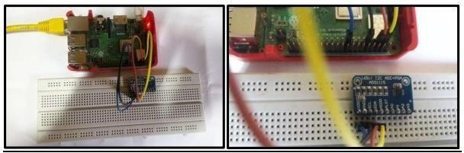
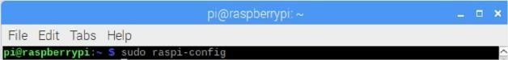
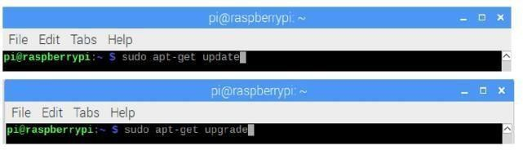
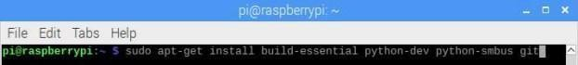

Step 1: Enable Raspberry Pi I2C interface

Go to Interfacing Options I2C Enable (Yes) Step 2: Update the Raspberry pi

Step 3: Install the Adafruit ADS1115 library for ADC
To install the dependencies starting with the Adafruit python module for the ADS115 chip, Ensure you are in the Raspberry Pi home directory ($ cd ~)

Next, clone the Adafruit git folder for the library by running

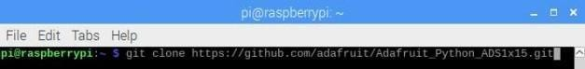
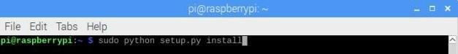
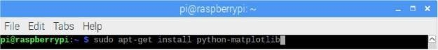

Change into the cloned file’s directory and run the setup file

Step 4: Test the library and 12C communication.
Now, it is important to test the library and ensure the ADC can communicate with the raspberry pi over I2C. To do this use an example script that comes with the library.
$ cd examples
$ python simpletest.py
If the I2C module is enabled and connections good, it should display the data as below
If an error occurs, check to ensure the ADC is well connected to the PI and I2C communication is enabled on the Pi.
Step 5: Install Matplotlib

With all the dependencies installed, we are now ready to write the code.
At this stage it is important to switch to a monitor or use the VNC viewer (or Remote Desktop Connection), anything through which you can see your Raspberry Pi’s desktop, as the graph being plotted won’t show on the terminal.

Source Code:
import matplotlib.pyplot as plt
from matplotlib.animation import FuncAnimation import Adafruit_ADS1x15
# Create an ADS1115 ADC (16-bit) instance adc = Adafruit_ADS1x15.ADS1115()
GAIN = 1
val = []
# Start continuous ADC conversions on channel 0 using the previous gain value adc.start_adc(0, gain=GAIN)
print('Reading ADS1x15 channel 0') fig, ax = plt.subplots()
ax.set_ylim(-5000, 5000)
ax.set_title('Oscilloscope') ax.grid(True) ax.set_ylabel('ADC outputs')
line, = ax.plot([], [], 'ro-', label='Channel 0') ax.legend(loc='lower right')
# Function to update the plot dynamically def update(cnt):
# Read the last ADC conversion value
value = adc.get_last_result() print(f'Channel 0: {value}') # Store new values val.append(value)
if len(val) > 50: val.pop(0)
# Update plot data line.set_data(range(len(val)), val)

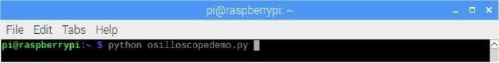
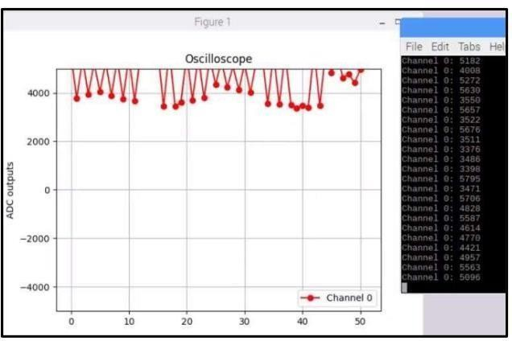
ax.relim() ax.autoscale_view() return line,
# Create animation
ani = FuncAnimation(fig, update, interval=500) plt.show()

Save the code and run using

That's all !!!
ADC data being printed on the terminal, and related Plot is also visible.

Internet of Things # Practical No: 4

Name |  | Roll No: | Type your text
Class | T.Y.B.Sc. Data Science | Seat Number:
Subject / Topic | Internet of Things
Topic | Controlling Raspberry Pi with telegram bot.

Practical No: 4 Controlling Raspberry Pi with telegram bot.

Requirement:
- Jumper wires (F to F).
- 8 LED Light Board.
- Smartphone with Installed Telegram App.

Hardware Connectivity:

LED Terminal | Pin Number | GPIO Number
led_pin1 | Pin 31 | GPIO 6
led_pin2 | Pin 33 | GPIO 13
led_pin3 | Pin 35 | GPIO 19
led_pin4 | Pin 37 | GPIO 26
Negative(ground) | Pin 9 | GND

Other Requirement:
  - Install Telegram App in Mobile . Follow process to obtain access token.

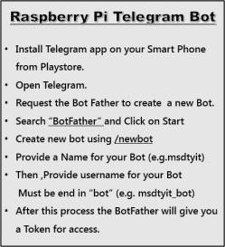

  - Install Telegram Bot on Raspberry Pi. # sudo apt-get install python.pip
# sudo pip install telepot

Source Code:
import time import datetime
import RPi.GPIO as GPIO import telepot
from telepot.loop import MessageLoop

# Define LED GPIO Pins LED1 = 6
LED2 = 13
LED3 = 19
LED4 = 26

# Initialize GPIO

GPIO.setmode(GPIO.BOARD)
GPIO.setwarnings(False)
for led in [LED1, LED2, LED3, LED4]:
GPIO.setup(led, GPIO.OUT) GPIO.output(led, 0)

# Initialize Telegram Bot
telegram_bot = telepot.Bot('6489494048:AAEPlW7QpyIW_ne8KNr1UvILgw2jkANvens') print(telegram_bot.getMe())

def action(msg):
chat_id = msg['chat']['id'] command = msg['text'].lower() print(f'Received: {command}')

message = ""

if 'on' in command: message = "Turning on " if 'led1' in command:
message += "LED1 " GPIO.output(LED1, 1)
if 'led2' in command: message += "LED2 " GPIO.output(LED2, 1)
if 'led3' in command: message += "LED3 " GPIO.output(LED3, 1)
if 'led4' in command:

message += "LED4 " GPIO.output(LED4, 1)
if 'all' in command: message += "ALL LEDs " GPIO.output(LED1, 1)
GPIO.output(LED2, 1)
GPIO.output(LED3, 1)
GPIO.output(LED4, 1) message += "light(s)"
telegram_bot.sendMessage(chat_id, message)

elif 'off' in command: message = "Turning off " if 'led1' in command:
message += "LED1 " GPIO.output(LED1, 0)
if 'led2' in command: message += "LED2 " GPIO.output(LED2, 0)
if 'led3' in command:
message += "LED3 " GPIO.output(LED3, 0)
if 'led4' in command:
message += "LED4 " GPIO.output(LED4, 0)
if 'all' in command: message += "ALL LEDs " GPIO.output(LED1, 0)
GPIO.output(LED2, 0)

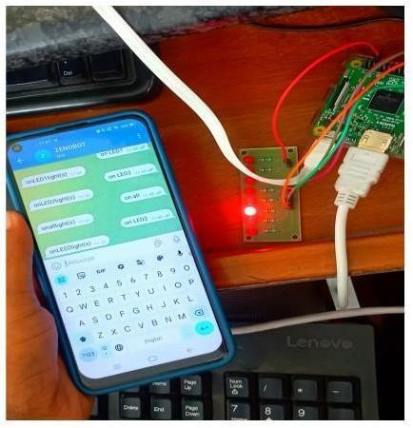
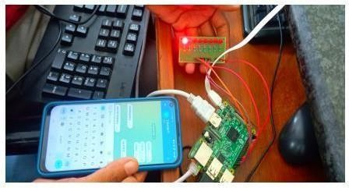
GPIO.output(LED3, 0)
GPIO.output(LED4, 0) message += "light(s)"
telegram_bot.sendMessage(chat_id, message)

# Start Telegram Bot Listener MessageLoop(telegram_bot, action).run_as_thread() print('Bot is running and waiting for commands...')

# Keep the program running while True:
time.sleep(10)

Output:

Internet of Things # Practical No: 5

Name |  | Roll No:
Class | T.Y.B.Sc. Data Science | Seat Number:
Subject / Topic | Internet of Things
Topic | Raspberry Pi GPS Module Interfacing.

Practical No: 5 Raspberry Pi GPS Module Interfacing.

Requirement:
- GPS module.
- USB to TTL converter.
- Connecting jumper wires (female to female).

Hardware Connectivity:
- Connect the VCC Pin of GPS Module to 3.3V Pin of USB to TTL converter
- Connect the GND Pin of GPS Module to GND Pin of USB to TTL converter
- Connect the Tx Pin of GPS Module to Rx Pin of USB to TTL converter
- Connect the Rx Pin of GPS Module to Tx Pin of USB to TTL converter.
- Lastly connect the USB to TTL converter to USB port of Raspberry Pi.

Commands:

Open Terminal Window and type the following command
  - To know to which USB port the GPS module is attached:
# ls /dev/ttyUSB*
  - Select USB Port
# sudo cat /dev/ttyUSB0
  - To install gpsd, make sure your Pi has an Internet connection and run the following commands:
# sudo apt-get update
# sudo apt-get install gpsd
  - You will need to enable the gpsd systemd service by running the following commands:
# sudo systemctl enable gpsd.socket # sudo systemctl start gpsd.socket
  - After that use the gpsd command
# gpsd
  - Try running gpsmon to get a live-streaming update of GPS data!
# gpsmon cgps
which gives a less detailed, but still quite nice output
# cgps -s
(NOTE:if your got command stuck use “CTRL + z” for exit that command)
  - You can abort gpsd by the following command
# sudo killall gpsd Output:

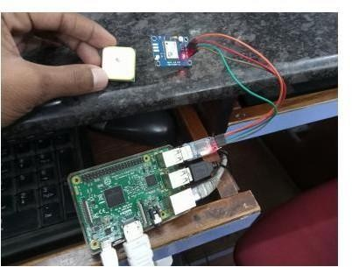
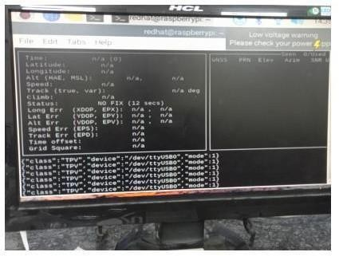
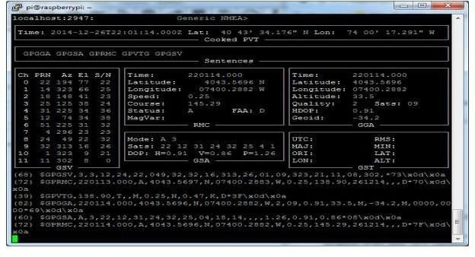

Internet of Things # Practical No: 6

Name |  | Roll No:
Class | T.Y.B.Sc. Data Science | Seat Number:
Subject / Topic | Internet of Things
Topic | IoT based Web Controlled Home Automation using Raspberry Pi

Practical No: 6 IoT based Web Controlled Home Automation using Raspberry Pi.

Requirement:
- 8LED light board
- Jumper wires (Female to Female)

Hardware Connectivity:
- Connect to Physical PIN 6 for GND.
- Connect to Physical PIN 17 with 8 LED Light Board.

Other Requirement:
- To update the raspberry Pi below commands and then reboot the RPi:
  - #sudo apt-get update
  - #sudo apt-get upgrade
  - #sudo reboot
- Now download the latest version of WebIOPi from the following link on your raspberry pi:
http://webiopi.trouch.com/DOWNLOADS.html

Commands:
- Installation of WebIOPi:
To update the raspberry Pi below commands and then reboot the RPi:
- sudo apt-get update
- sudo reboot
- Now download the latest version of WebIOPi from the following link on your raspberry pi:
http://webiopi.trouch.com/DOWNLOADS.html
- move to the downloads folder using the command:
cd /home/pi/Downloads/
- extract the file and adapt x.y.z with the version you download:
  - tar xvzf WebIOPi-x.y.z.tar.gz
  - cd WebIOPi-x.y.z
- Below commands are used to install patch while still in the WebIOPi directory, run:
  - wget https://raw.githubusercontent.com/doublebind/raspi/master/webio pi-pi2bplus.patch
  - patch -p1 -i webiopi-pi2bplus.patch
- run the setup installation for the WebIOPi using:
  - sudo ./setup.sh
- reboot your pi:
  - sudo reboot
Test WebIOPi Installation:

For instance, to start with verbose output and the default config file:
- sudo webiopi -d -c /etc/webiopi/config
7. start/stop the background service, the configuration will be loaded from
/etc/webiopi/config.
- sudo /etc/init.d/webiopi start
- sudo /etc/init.d/webiopi stop
- NOTE:
You can also start/stop the background service, the configuration will be loaded from
/etc/webiopi/config.
- # sudo /etc/init.d/webiopi start
- # sudo /etc/init.d/webiopi stop
- Ip address
cmd - # ifconfig ( copy inet/ip address ) https;//copiedIPaddress:8000 (eg: http://192.168.0.123:8000)
- then enter userID and Password:
username: webiopi password: raspberry
After then click on the GPIO header link. Wiring up your circuit:
For this test, we will be connecting an LED to GPIO 17, so go on and set GPIO 17 as an output.

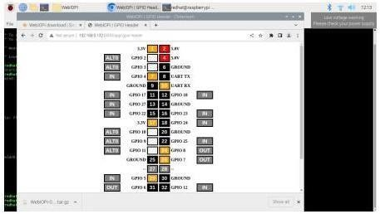
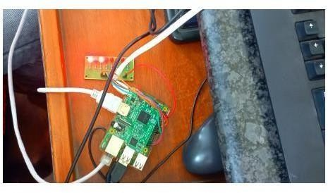
Output:

Internet of Things # Practical No: 7

Name |  | Roll No:
Class | T.Y.B.Sc. Data Science | Seat Number:
Subject / Topic | Internet of Things
Topic | Visitor Monitoring with Raspberry Pi and Pi Camera

Practical No: 7 Visitor Monitoring with Raspberry Pi and Pi Camera.

Requirement:
- Raspberry Pi Camera Module Hardware Connectivity:
  - First you have to connect Camera Module to Raspberry Pi ‘s Camera port.
  - Then open Terminal window and type command as follow:
# sudo apt-get update # sudo raspi-config
  - Go to Interface Option and enable Camera and I2C option.then click on Done option.
Select Interfacing Options » Camera » Enable Select Interfacing Options » I2C » Enable
  - After this reboot the system, using command:
# sudo reboot

Source Code:
from time import sleep
from picamera import PiCamera

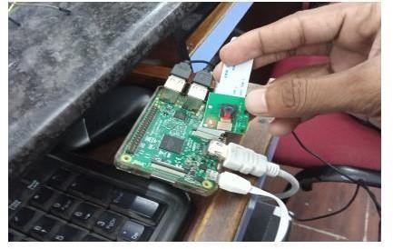
# Initialize Camera camera = PiCamera()
camera.resolution = (1280, 720)

# Allow Camera to Warm Up sleep(2)

# Capture Image camera.capture('/home/pi/Pictures/newImage.jpg')

# Stop Camera Preview camera.close()

Output:

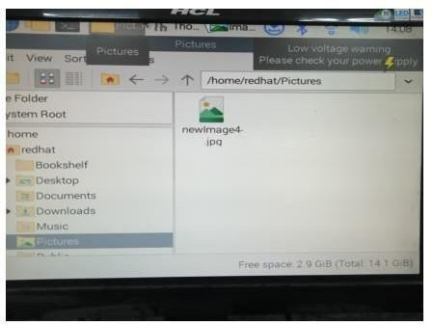

Internet of Things # Practical No: 8

Name |  | Roll No:
Class | T.Y.B.Sc. Data Science | Seat Number:
Subject / Topic | Internet of Things
Topic | Interfacing Raspberry Pi with RFID.

Practical No: 8 Interfacing Raspberry Pi with RFID. Requirement:
- RFID Reader (RC 522)
- RFID Tags or Cards
- Jumper wires (Female to Female).

Hardware Connectivity:

RFID READER BOARD PIN | RPi PHYSICAL PIN
SDA | 24
SCK | 23
MOSI | 19
MISO | 21
GND | 6
RST | 22
3.3V | 1

Other Requirement:
  - To enable P4 SPI :
# sudo raspi-config
  - To Restart your Paspberry Pi
# sudo reboot
  - To see if spi_bcm2835 is listed

# lsmod | grep spi
  - To update
# sudo apt-get update
  - Setting up the RFID reader
# sudo apt-get install python3.dev python3.pip
  - spidev library helps handle interactions with the SPI
# sudo pip3 install spidev
  - MFRC522,py which is an implementation of the RFID RC255 interface
# sudo pip3 install mfrc522

Source Code:
import RPi.GPIO as GPIO
from mfrc522 import SimpleMFRC522

# Initialize RFID Reader reader = SimpleMFRC522()

# Writing Data to RFID Tag def write_rfid():
try:
text = input("New Data: ")
print("Now place your tag to write...") reader.write(text)
print("Data written successfully!") finally:
GPIO.cleanup()

# Reading Data from RFID Tag def read_rfid():
try:
print("Place your tag to read...") id, text = reader.read() print(f"ID: {id}")
print(f"Data: {text}") finally:
GPIO.cleanup()

# Main Execution
if name == " main ":
choice = input("Enter 'w' to write or 'r' to read from RFID: ").strip().lower() if choice == 'w':
write_rfid() elif choice == 'r':
read_rfid() else:
print("Invalid choice. Please enter 'w' or 'r'.")

Output:

